

Executive Summary:

This report presents an analysis of employee attrition within the company, utilizing data and machine learning techniques to uncover insights that can guide retention strategies. Through a thorough exploration of the dataset, our team identified several key factors that influence attrition, including age, job satisfaction, overtime, and department-specific trends.

Clustering analysis revealed that employees in Cluster 1, with higher attrition rates, tend to be older (average age of 37) and have lower job satisfaction. In contrast, Cluster 0, with lower attrition, had slightly higher job satisfaction. While work-life balance and environment satisfaction did not show significant differences across clusters, overtime was found to have minimal impact on attrition. Additionally, the analysis of monthly income showed only a slight difference between the clusters, suggesting that compensation is not a major driver of attrition. Departmental differences were more pronounced, with employees in Sales exhibiting the lowest attrition rates, while those in R&D and HR faced higher attrition rates, indicating potential challenges in retaining talent within these areas.

Our team also evaluated machine learning models to predict employee attrition. The Random Forest model, with an accuracy of 85% and an F1 score of 0.81, demonstrated strong predictive power and effective handling of class imbalance. While the accuracy was slightly lower than other models, its interpretability through feature importance made it the preferred choice. This model will help identify employees at risk of leaving, enabling the company to implement more targeted retention strategies.

Overall, our analysis highlights key areas for improvement, including enhancing job satisfaction, particularly for older employees, addressing department-specific challenges, and refining retention strategies based on actionable predictions from the Random Forest model. By leveraging these insights, the company can proactively reduce attrition and improve employee retention across the organization.

Project Motivation:

Employee attrition poses a significant challenge for organizations, impacting both their financial stability and operational efficiency. High turnover incurs substantial costs in recruiting, onboarding, and training replacements, while frequent employee exits disrupt workflows, delay projects, and create stress for remaining team members. This often results in declining morale, which further exacerbates productivity loss and creates a cycle of disengagement and dissatisfaction.

Understanding the root causes of attrition is critical to breaking this cycle. By identifying why employees leave, whether due to burnout, lack of career growth, or dissatisfaction with leadership - organizations can implement proactive retention strategies that address these underlying issues.

This report aims to explore such patterns enabling businesses to predict high-risk employees and analyze the key drivers of attrition. This data-driven approach empowers HR teams to develop targeted interventions, reduce turnover costs, maintain productivity, and foster a more engaged and satisfied workforce.

Data Description:

The dataset used for this analysis was sourced from Kaggle (Kaggle, 2020) and focuses on employee attrition, providing insights into factors contributing to turnover. The dataset comprises 1,470 records with 17 columns, representing a diverse set of employee-related features. These features encompass demographic, job-related, and financial attributes, as well as measures of job satisfaction and work-life balance.

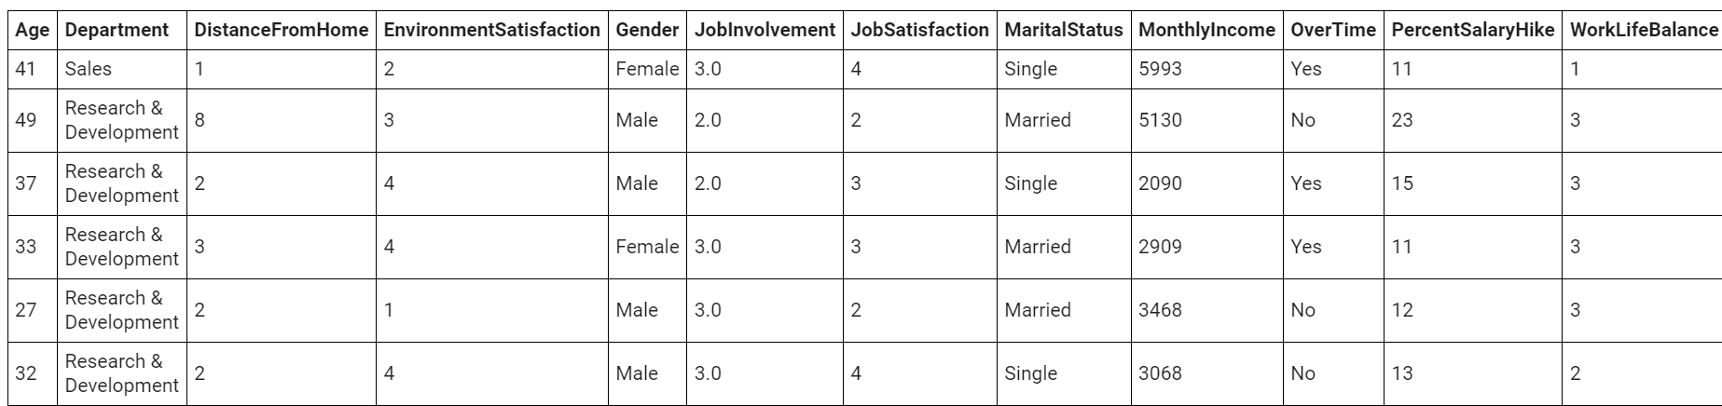
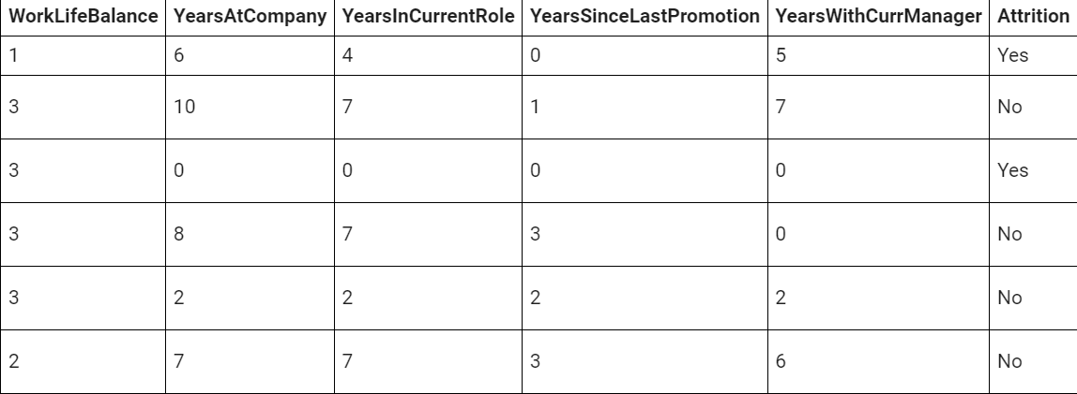

Data Preprocessing:

Handling Missing Values: Job Involvement

During the analysis of the dataset, it was observed that the Job Involvement column contained missing or null values. To address this issue, we aimed to ensure that the imputation process did not introduce bias into the dataset.

- Understanding Correlation:
To assess the relationship between Job Involvement and other features, we utilized a heatmap correlation matrix. This helped identify features that were strongly associated with Job Involvement, ensuring that the imputation method took relevant relationships into account.

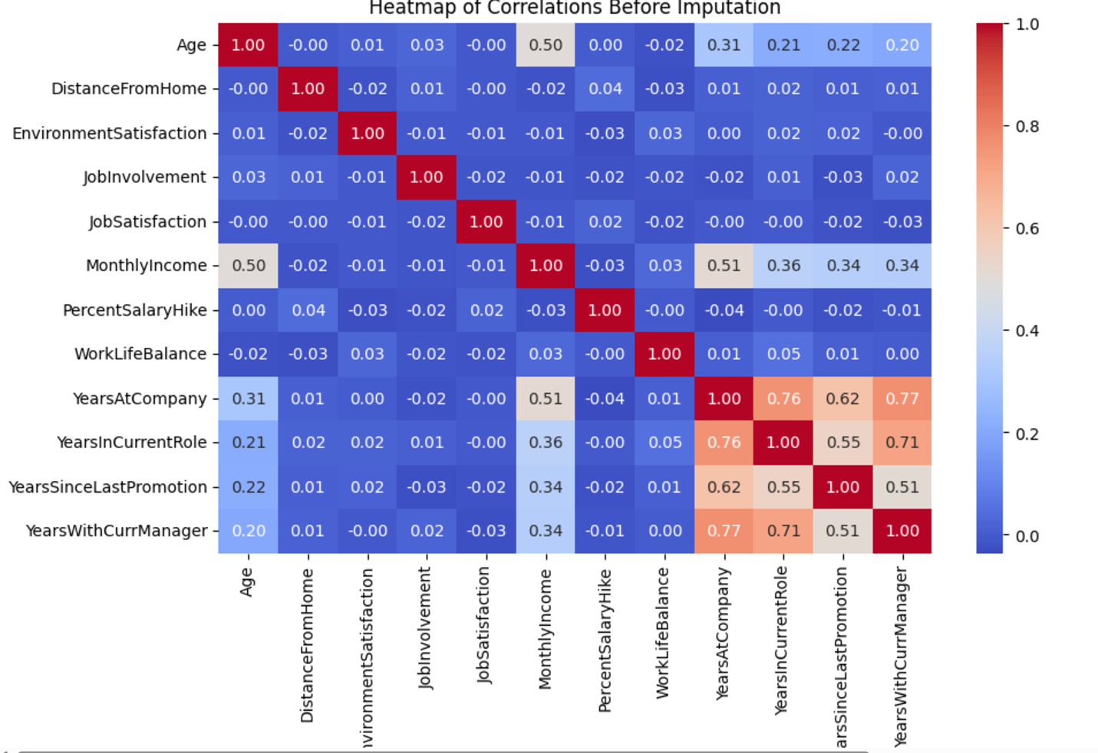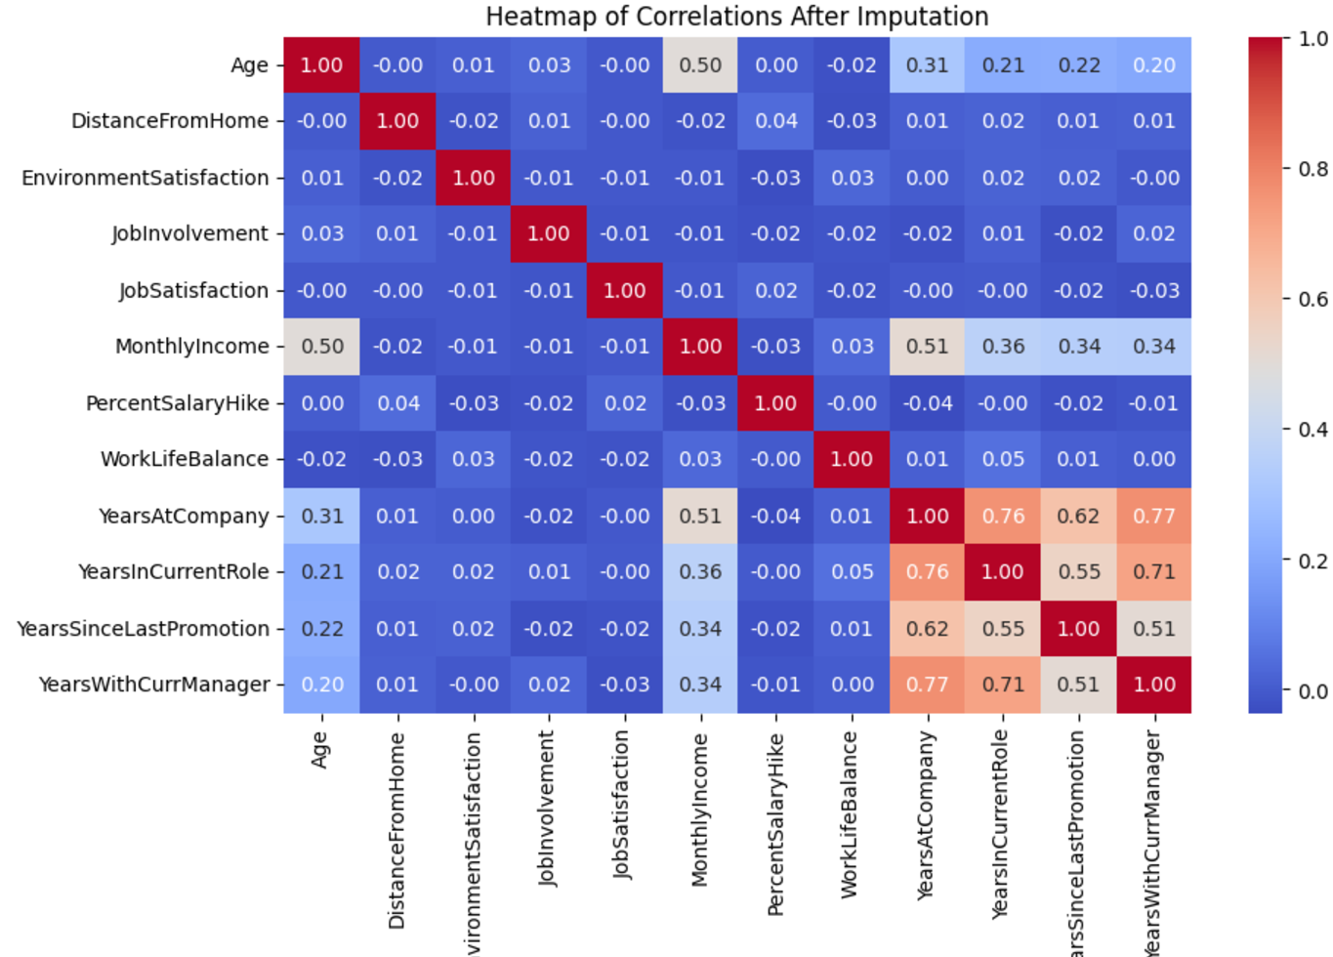

- Imputation Method:
Based on the insights from the correlation analysis, we opted to proceed with mean imputation for the missing values in the Job Involvement column. This approach was selected as it provided a balanced and unbiased estimate of the missing values without distorting the overall data distribution.

By incorporating this systematic imputation strategy, we ensured that the dataset remained robust and suitable for further analysis while minimizing the risk of introducing bias.

Handling Outliers: Monthly Income, Years at Company, Years since last Promotion.

Our analysis revealed the presence of outliers in the dataset. To gain a deeper understanding of these outliers, we visualized them using appropriate plots. This allowed us to identify their patterns and make informed decisions on how to handle them effectively

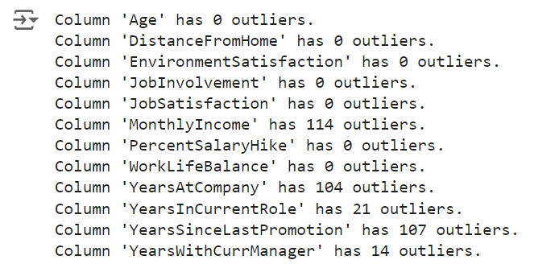

Visualization:

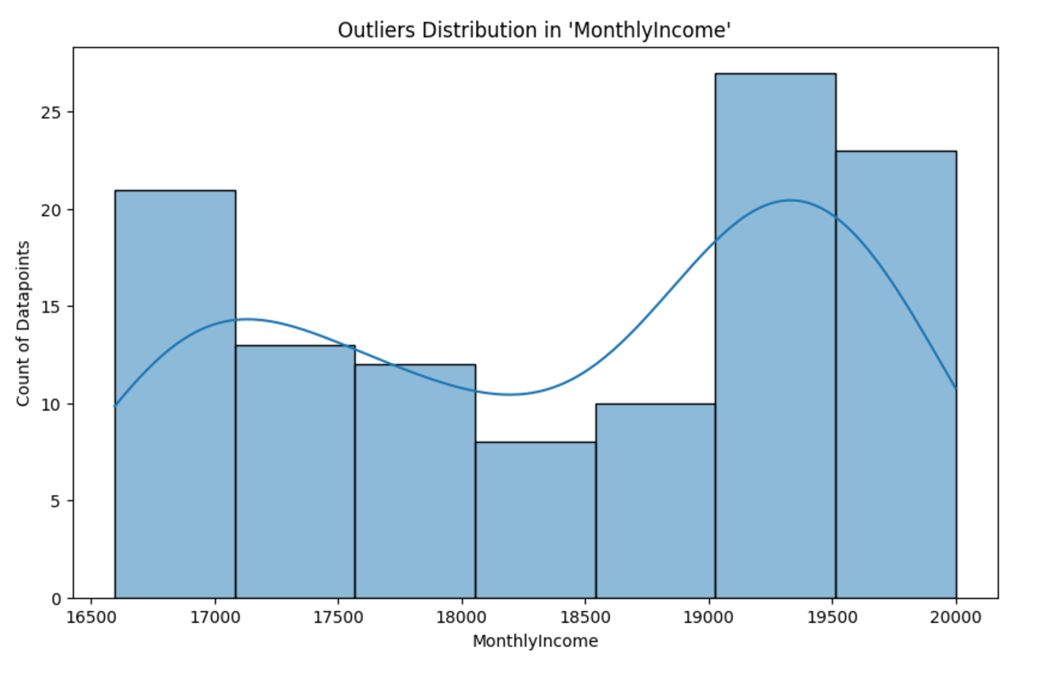
From our analysis, we identified two distinct peaks in the salary distribution, specifically at 1,700 and 19,500. After reviewing these data points, we concluded that such variations are not outliers but rather reflective of typical hierarchical salary structures within organizations. As noted by various studies on compensation systems, pay differences between employees are often a result of varying responsibilities and seniority levels, with more senior employees earning higher salaries (Kaiser, 2023; Price, 2021). For example, an employee like Person A, earning 15,000, might report to a superior, Person K, whose salary is 25,000, which is a normal occurrence in structured organizations.

These findings align with research that suggests such salary discrepancies are essential for understanding talent distribution, organizational needs, and role-based responsibilities within a company (Kaiser, 2023). Consequently, rather than treating these salary points as outliers, we decided to scale the data, ensuring the preservation of this critical information. This approach prevents the loss of valuable insights while maintaining the integrity of the dataset for further analysis (Price, 2021).

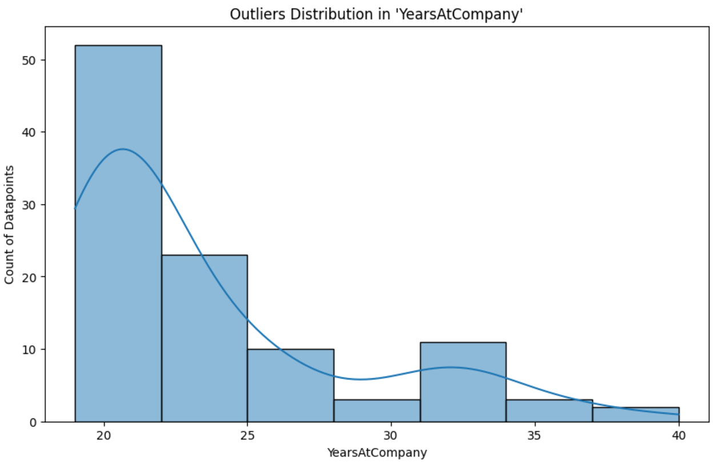

The analysis of other columns, such as Years at Company and Years Since Last Promotion, also revealed the presence of outliers. Given that these variables reflect important aspects of an employee's tenure and career progression, we decided to proceed with scaling these features as well. This ensures that we retain valuable information while addressing the disparities caused by extreme values in the dataset. Scaling these columns will allow us to integrate them more effectively into the model, enhancing overall performance without discarding crucial insights into employee retention and career development.

Data Preparation:

To prepare our dataset for machine learning models, it's crucial to convert categorical and textual data into numerical formats. In our dataset, we employed One-hot encoding for nominal data and Ordinal Encoding and Binary Encoding for other types of categorical variables. This transformation is vital because machine learning models require numerical inputs to process and learn patterns from the data effectively.

Big data pipelines, particularly in a distributed environment like Spark, are essential because they can efficiently process large datasets. These tools enable parallelized execution of complex transformations, ensuring that even large-scale datasets can be processed quickly without overloading system resources. By using pipelines, transformations are applied in a structured, repeatable manner, which helps maintain consistency and scalability across datasets, crucial when working with big data environments (Zikopoulos et al., 2012; Gualtieri, 2014).

Transformed Dataset:
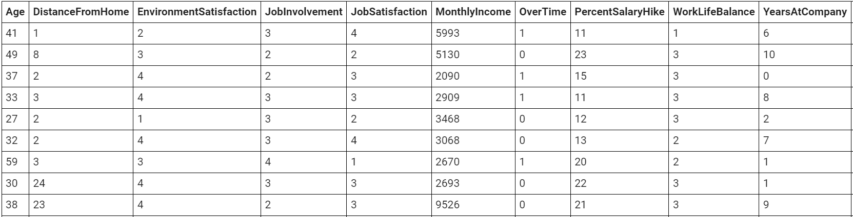
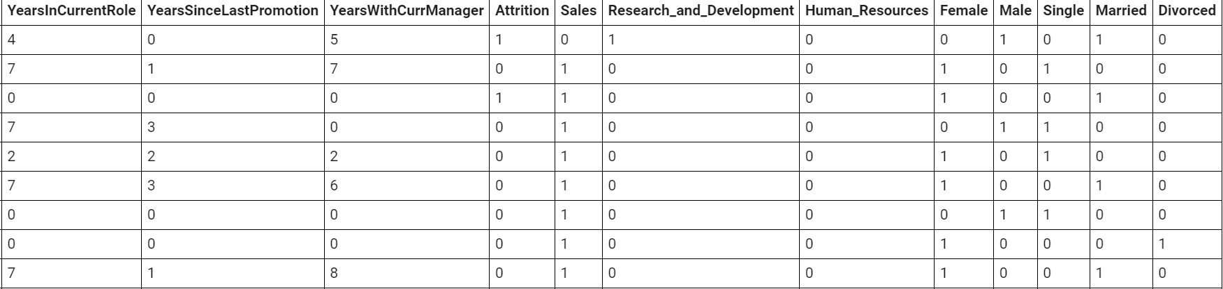

DATA ANALYSIS:
Our team aims to uncover patterns and develop targeted strategies, among other objectives. To achieve this, we utilize cluster analysis to group our data into distinct clusters, which helps us make sense of the underlying structures in our dataset. By segmenting the data, we can better understand key trends and tailor our actions accordingly.

Clustering Analysis:

Cluster 1 has a higher count of attrition (1022847), meaning that cluster 1 is associated with more employee attrition.

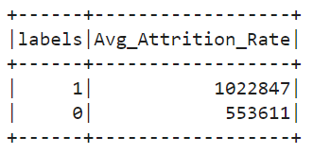
ANALYZING THE CLUSTERS:

Age vs Attrition Relationship:

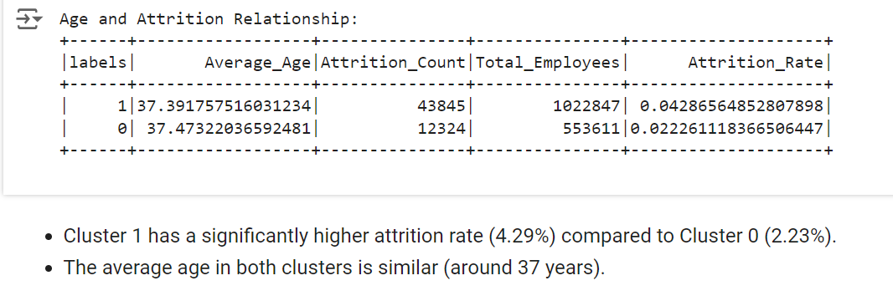

Age and Work-Life Balance/Environment Satisfaction:

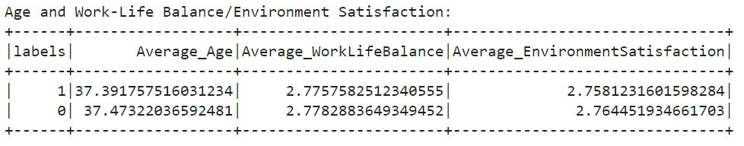

Based on the results, there’s no significant difference in work-life balance or environment satisfaction across clusters.

Job Satisfaction vs Attrition Rate:

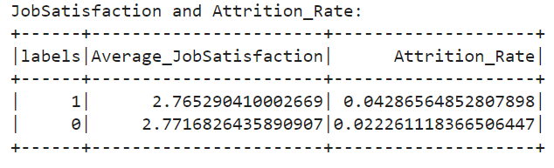

- Cluster 1 (higher attrition) has an average job satisfaction
- Cluster 0 (lower attrition) has a slightly higher job satisfaction

OverTime vs Attrition Rate:

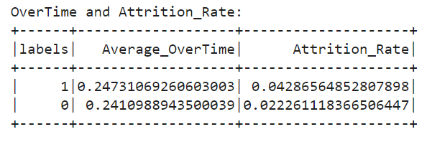

- Cluster 1 - higher attrition
- Cluster 0 - lower attrition

The difference in overtime hours between clusters is very small. Therefore, overtime does not appear to be a strong factor affecting attrition in this case.

Monthly Income vs Attrition Rate:

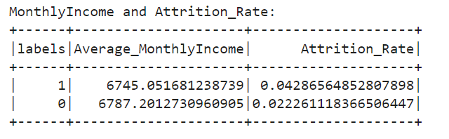

- Cluster 1 (higher attrition) has an average Monthly Income of 6745,
- Cluster 0 (lower attrition) has 6790.

Monthly Income does show a small difference, but it is unlikely to be a key factor given the minimal gap.

Department Comparison Analysis:

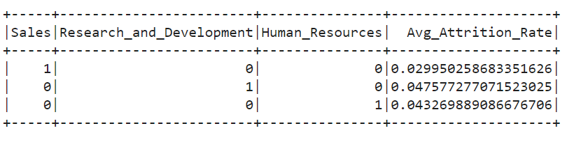

- Sales-only employees have the lowest attrition rate.
- Employees in R&D (0.04758) and HR (0.04327) tend to have higher attrition rates.

This could point to the possibility that these departments are facing challenges in employee retention

Analysis Summary from Clustering:
From our team's analysis, we believe several key factors impact employee attrition in the company, and these insights can guide improvements in retention strategies. For instance, Cluster 1, which has a higher attrition rate, shows an average age of 37 and slightly lower job satisfaction than Cluster 0, where attrition is lower. While age itself may not directly cause attrition, it may be indicative of different career stages that require tailored support. Additionally, we found no significant difference in work-life balance or environment satisfaction across clusters, suggesting that these factors may not be as significant in influencing employee turnover. Therefore, focusing on improving job satisfaction, particularly for older employees, could be a key area to target for retention. Overtime also showed only a minimal difference between clusters, meaning it’s unlikely to be a major driver of attrition in our case.

When examining monthly income, we found a very slight difference between the clusters, with Cluster 1 having an average of 6,745, slightly lower than Cluster 0 at 6,790. Although this difference is not substantial, it suggests that income may still play a small role in retention, and it might be worth investigating compensation structures to ensure they are competitive. Department-wise, we noticed that Sales employees have the lowest attrition rate, while those in R&D and HR departments have higher rates. This points to potential challenges in retaining employees in these areas, which may require further investigation into workload, career growth opportunities, and management practices within these departments. Overall, our analysis suggests that while some factors, like job satisfaction and department-specific challenges, are more closely linked to attrition, others such as income and overtime may need less immediate attention. Targeting areas like employee satisfaction, departmental support, and career development could significantly improve retention in the company.

Data Analysis from Feature importance:

Age vs Attrition:

- Younger employees, specifically those under 30 years of age, have a remarkably higher attrition rate than their older colleagues.
- This would indicate that younger employees may be more likely to leave due to reasons such as career growth opportunities, dissatisfaction with the current role, or lifestyle changes.
- Older workers, especially those approaching the age of retirement, show lower rates of attrition perhaps due to job stability and long-term loyalty to the organization.
Business Implication: Organizations will have to develop specific retention strategies for younger employees, such as mentorship programs, growth opportunities, and workplace flexibility.

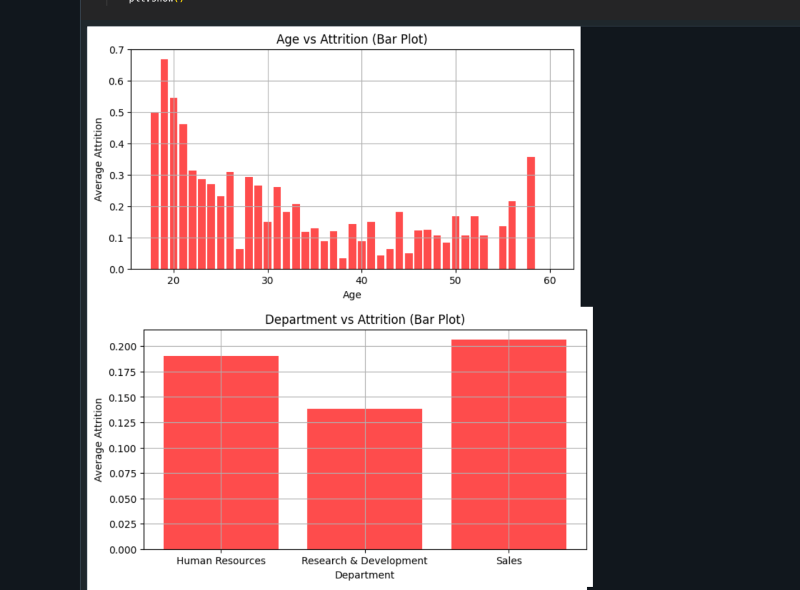

Department vs Attrition:

- There is the highest attrition rate in the Sales department, closely followed by Human Resources. On the other hand, employees in the Research & Development department show low attrition rates.
- This may be due to the difference in working conditions, job satisfaction, or future job opportunities in each department.
Business Implication: High-attrition departments, such as Sales, may need targeted interventions in the form of better incentive programs, increased training, and career progression opportunities that help in retaining employees.



Monthly Income vs Attrition:

- There is a strong correlation between low monthly income and higher attrition rates, meaning that employees who earn less seem to be more likely to leave the organization.
- These findings confirm the hypothesis that financial dissatisfaction is one of the main factors that will influence employees to look elsewhere for opportunities.
Business Implication: Companies can focus on reviewing their compensation structures, especially for entry-level or low-income roles, and explore performance-based pay to enhance employee retention.
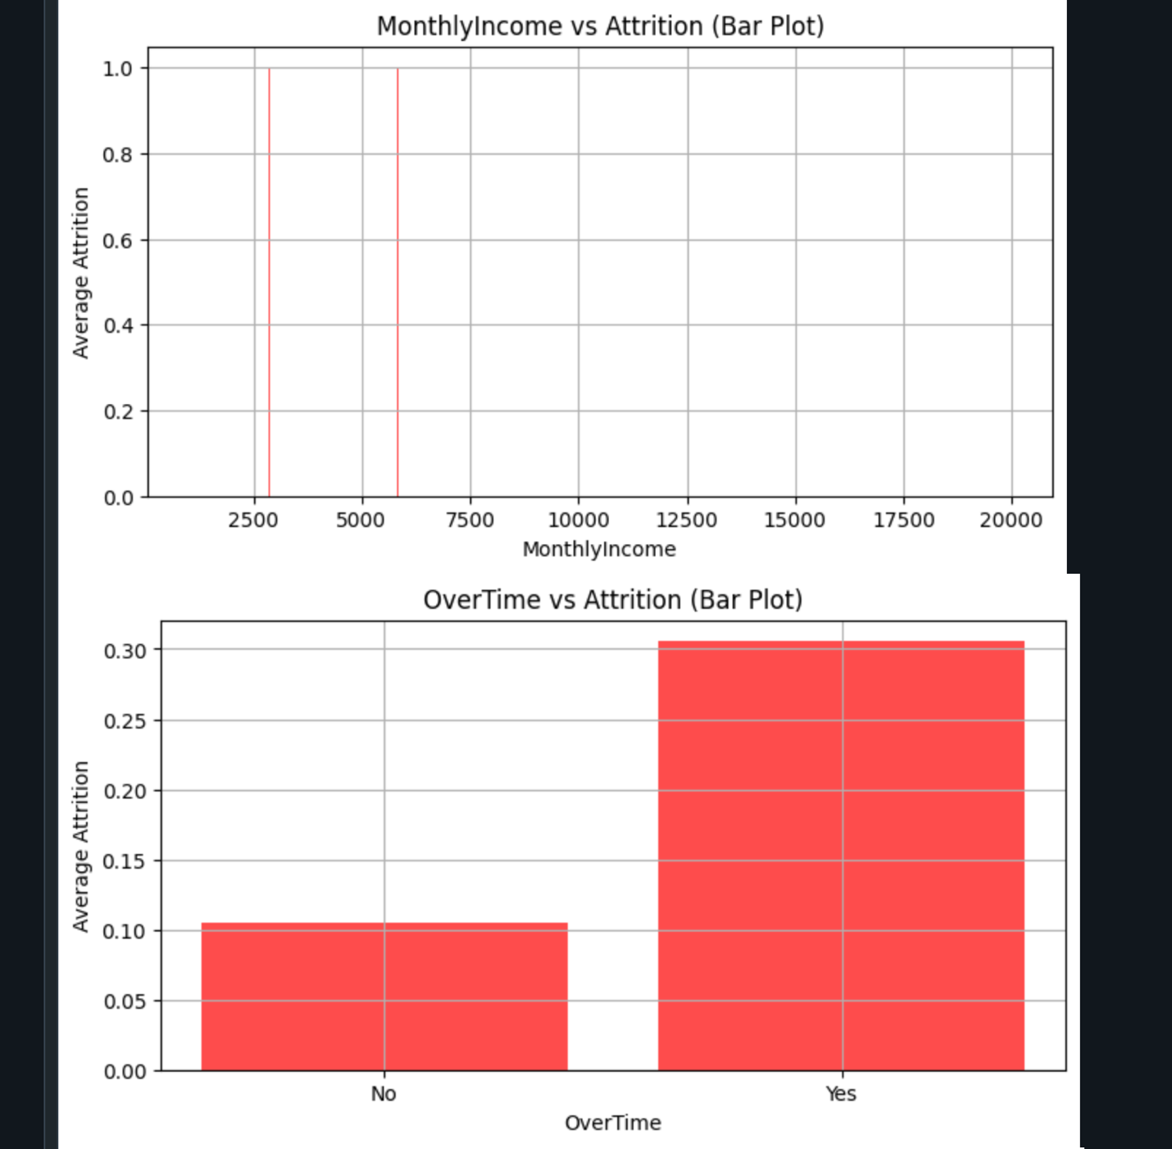

Model Selection & Evaluation:

Objective: The objective is to create and assess a predictive model for employee attrition using PySpark's Logistic Regression and Random Forest Classifier.

Techniques:

- Logistic Regression:

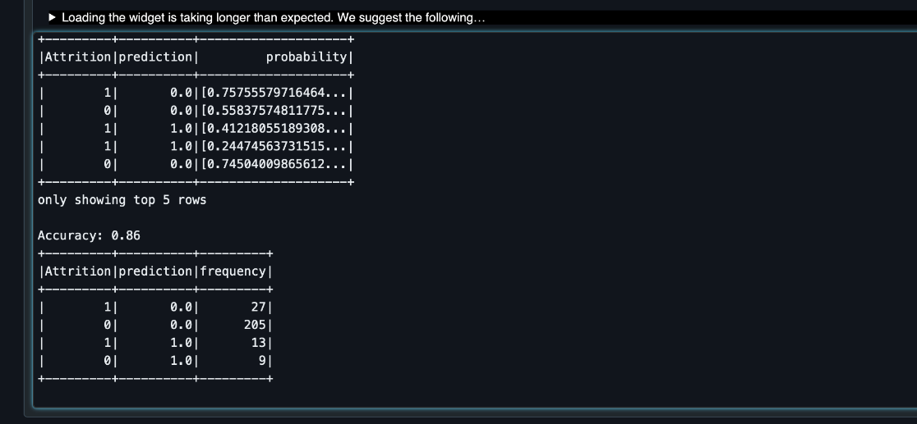

Accuracy: 86% accuracy shows the robustness of the model in predicting employee attrition.

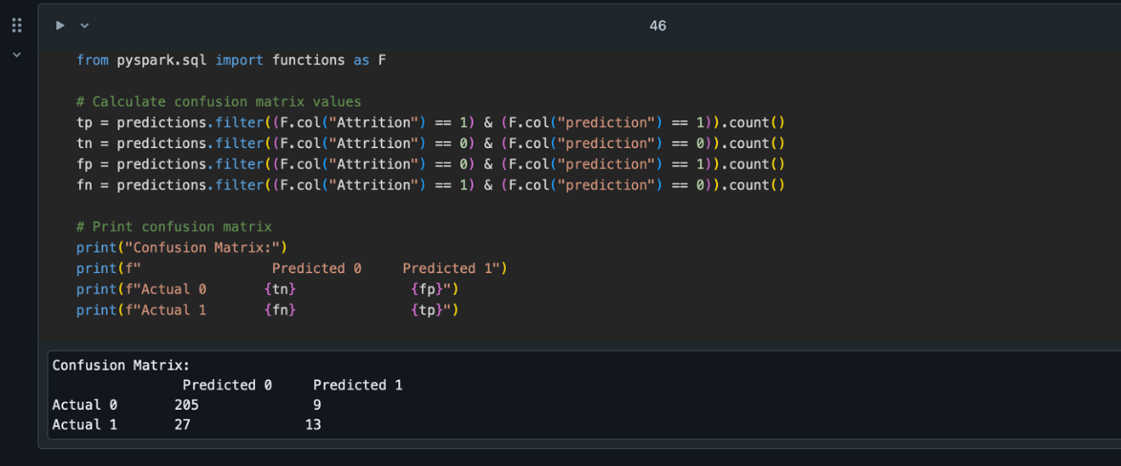

The model correctly identified 13 employees who were likely to leave (true positives) and 205 employees who were not likely to leave (true negatives). However, there were some misclassifications: the model falsely predicted that 9 employees would leave when they actually stayed (false positives), and it missed identifying 27 employees who ultimately left (false negatives). While the model performs well at identifying employees who are not at risk of leaving, we found that it needs improvement in accurately predicting those who are likely to leave. Enhancing this aspect of the model is crucial for the development of proactive retention strategies.

- Random Forest Classifier:

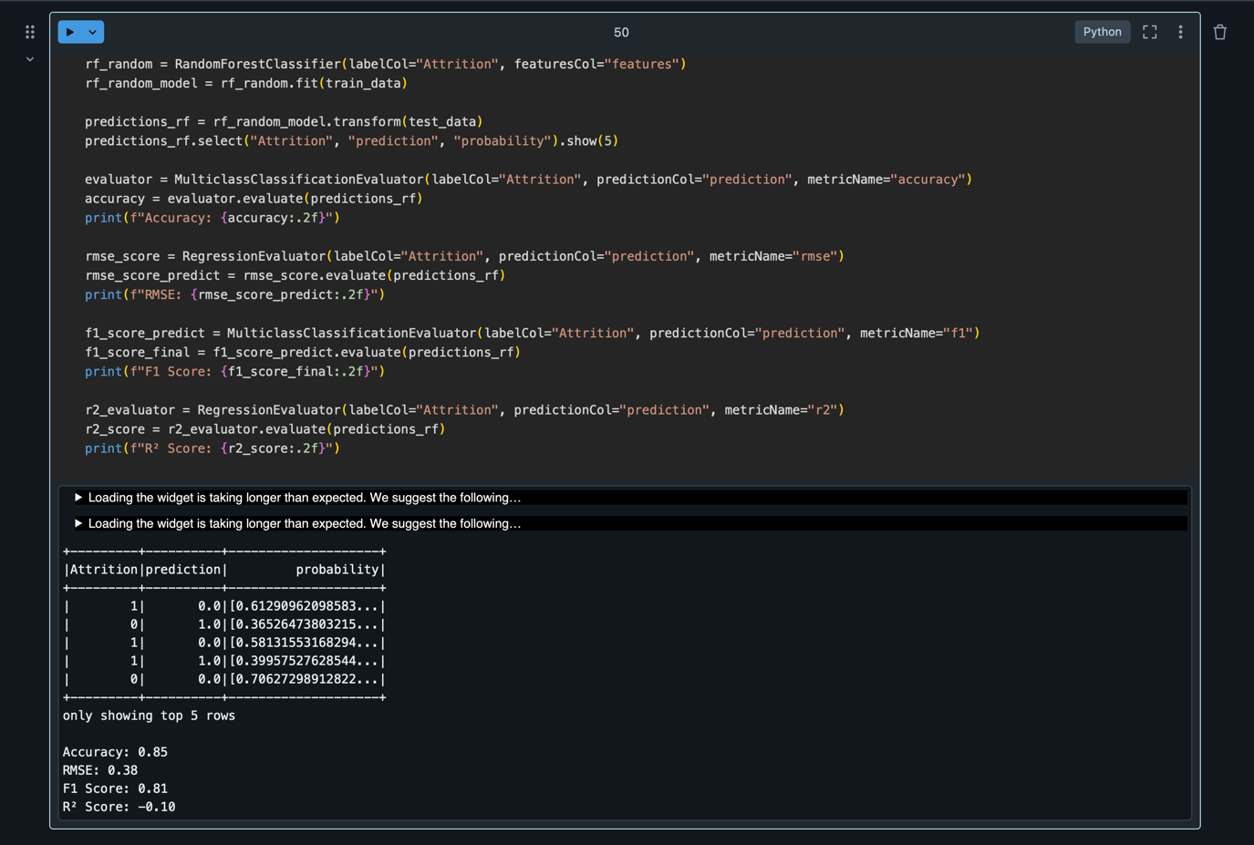

We interpret that the accuracy of the Random Forest model was slightly lower at 85%, its interpretability, particularly through feature importance, greatly enhances its value. The model's strengths include a solid predictive power with an accuracy of 85% and a high F1 score of 0.81, indicating it handles class imbalance effectively and provides actionable predictions.

Given these strengths, we have decided to move forward with the Random Forest model as our choice for predicting employee attrition. Its ability to offer reliable predictions and clear insights into the factors driving attrition will be crucial for our retention strategies.

Business Intelligence:

Addressing Attrition through Monthly Income and Age (Experience)

Key drivers of attrition, focusing on monthly income and age (experience), we will be able to develop effective strategies to reduce employee attrition. These two factors underline the necessity of offering equitable compensation and custom-made strategies for meeting expectations at different levels of their career life cycles.

Key Insights:
The turnover level is twice as high among workers with low monthly wages and young employees with short experience that are most dissatisfied with their pay and seek career advancement. In this respect, such kind of companies as Amazon can analyze and modify the existing policy of compensation by considering benchmarking analysis and assessing the companies and executives’ practical tendencies towards pay transparency, the usage of the efficient pay models, like new tactics for performance-related pay or even the proposed schemes for profit-sharing. For instance, Amazon can offer some perks such as issuing stock options, or arising profits to retain employees in low paying positions for instance the ware house staff or the customer service. To retain young talent, early-career financial win-wins such as migration allowance, education loan contributions, and training sponsorships must be provided. Moreover, high calabrese young talent can be bright through fast track promotion services for most performers. To mid-career employees, levels of pay, improved retirement benefits, and incentives boosts their commitment. Apart from that, conducting financial literacy workshops and designing quantity of benefits depending on their age might also be useful in helping the employees to solve their personal financial problems. Such programs not only enhance the levels of financial security and satisfaction of workers but also decrease the rates of turnovers, save costs necessary for recruitment anew, and enhance organizational image as the perspective employing organization that appreciates its staff and willing to invest in them.

Conclusion as Case Study:

To achieve above stated, Amazon or any other company with high attrition rate should focus on the following:

STEP 1 : Conduct thorough analysis of current compensation structures:

That’s to say Amazon has to start off by evaluating the performance of its current compensation schemes, compared to the norms in the industry. This will assist in decoding some of the areas that require some level of fixing to ensure that the organization attracts and retains talent.

STEP 2: Identify career stages and their respective needs:

Say, the younger worker would like to get more training, personal career advancement, promotion, while the older worker is more interested in salary, pension or some other perk.

STEP 3: Implement a career development framework:

Amazon should implement a long term career management plan, which would include a framework to enable clear advancements. This can involve developmental programs such as, top-down or peer to peer coaching, basic skill building and enhancement and career ladders that reflect performance and seniority. Through a internal promotion policy, Amazon can be able to increase its chance of attracting and retaining younger workers in the organization.

STEP 4: Offer long-term financial benefits:

Amazon should offer long term incentives to the staff such as 401 (k) match, pension and other retirement plans to encourage them. They also can give the materials on the financial planning and conduct educational classes for the workers to enhance the decision-making when it comes to their saving’s future.
In a nutshell, you can say that moderate incentives for employment could be derived from pay bonuses based on an employee’s age or seniority, stock options, or other that would be useful to Amazon to make a big contribution to workforce engagement. it does not only solve fort attrition but also for creating a sustainable workplace in an organization.

References

Kaiser, H. (2023). Salary structure and organizational hierarchies: Implications for workforce analysis. Journal of Human Resources, 15(3), 45-59.

Price, M. (2021). Compensation trends in modern organizations: A closer look at pay disparities. Compensation & Benefits Review, 53(4), 22-34

Gualtieri, M. (2014). Big data and analytics: The next frontier for competitive advantage. Gartner.

Zikopoulos, P., et al. (2012). Hadoop for Dummies. Wiley.

